Dashing expectations: textual interventions, visual and representational strategies
Janice Andreae
Foreword
This review essay carries numerous traces of Barbara Godard’s influence on my viewing practice and my practice of reading visual and literary texts in a material way. Indeed, she taught me a different way of thinking about the processes of seeing, reading, and writing. Looped into my text are threads of her literary investigative processes: her play with (material) signifiers (“Preface.” Picture Theory 10); her border blurring of literary and visual sights/sites; her way of opening up a conversation, incorporating critical practice into the process of writing.

She introduced me to a fluid way of speaking of/to texts in relation to one another as if the process of art making and meaning making is a bridge spanning and generating texts built from the materials of everyday life. Her commitment of speaking to and writing about feminist interventions in Canadian literary practices shifted my own to examining sites of rupture generated by feminist and queer artists who employ text as a material in their visual practice.

Elena Basile writes of Barbara’s approach to writing as a conversation, “a work in progress meant to contribute to multiple networks of social and cultural meaning” (Basile 5). In contrast with the tradition of ekphrastic writing, she neither describes nor pays homage to a text but converses with it. Like Virginia Woolf, Barbara knew that “painting and writing have much to tell each other,” and that this continuing process of conversation interests readers (Woolf Collected Essays 2: 241; Yale Review 24.1: 62). She actively responded to “the mixing and marrying of words that goes on” (241; 63) in the writing process and adeptly employed her lens to glimpse barely visible detail, to read between the lines, and “to inscribe [that] reality in words, … [its] sensations, [its] experience” as it happens, not after its occurrence (Godard 18). Writing, she engaged her readers and shared her own engagement reading text, because “literature,” she notes, “does not come from life, it comes from other texts, it comes from language and the body writes things down” (“SP/ELLE: Spelling Out the Reasons.” Room of One’s Own 8.4: 18; “Flying Away with Language.” Lesbian Triptych 21).

The following text is generated from my response to the relations I experience between the visual art works I see as I wander through two exhibition spaces: The Writing is on the Wall, Museum London and Alpha Beta Data, Akau Inc., Queen Street West, Toronto.¹ At Akau Inc. I use a process of unravelling the connections I see between visual text works and at Museum London, Jamelie Hassan’s ى Manuscript Page provides me with a lens for seeing and speaking to the relations between the works. This process also informs my approach to writing the unravelling process I experience with each viewing, and it is consistent with the fabric of interconnected, textual relations at each site.

I use the present tense. I prefer this to writing in the past as if I am removed from my experience of the work and my act of writing is a way of representing it. Instead, I see the process of writing/reading artwork as I experience it as an act of inscribing that reality, and I see critical practice as a site “where theory and practice are united in the writing and the reading,” remembering Barbara’s words, reading from “Why this Book?” (Godard et al. “Editorial Statement.” 3; Marks and de Courtivron xiii)

Transgression implies that the limit is always at work.
(Derrida 12)

Literature does not come from life, it comes from other texts …
(Godard 18)
Two recent exhibitions, Alpha Beta Data and The Writing is on the Wall, provide an occasion for exploring the work of visual artists who practise a transgressive use of text. They offer, as well, an opportunity to discuss the innovative curatorial practices of Cheryl Sourkes and Andrew Hunter, respectively. Each focuses on the visual practice of the artists selected, along with the diverse ways their strategic use of text plays visually with what the viewer/reader sees and identifies as written text or visual art.

Hunter sees his project “as an opportunity to consider and to reflect on the conceptual threads, layered histories and artistic strategies that have informed individual artists’ decisions to incorporate text, graphic symbols and written narratives into what are traditionally defined as visual forms of expression” (Hunter). He scanned the permanent collection of Museum London for work that incorporated text visibly in its production: the earliest from 1890, the latest Jamelie Hassan’s ى Manuscript Page, 1996/2005, that I’ll use to direct my reading.

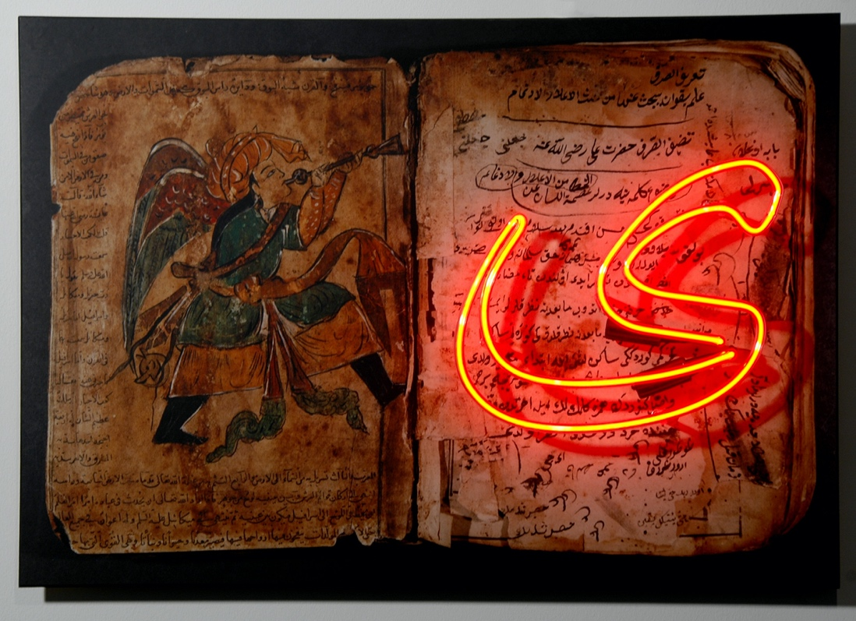
(Hassan, ى Manuscript Page)

Hassan’s text work recalls the pages of an Arabic/Persian manuscript, with a difference: ى Manuscript Page is photo-based and incorporates colour photography and neon lighting. It was created specifically for the international Biennial exhibition Imagining the Book, held in April 2005 to present contemporary artists whose work responded to the idea of the book, and later added to Museum London’s permanent collection. Hassan notes the same manuscript appears often in other work she made in the 1990s. ى Manuscript Page is structured in the following way: the last letter of the Arabic alphabet ى is overlaid onto the text of the last page. On the facing page is “a painted image of the Angel Gabriel in its classic Persian version with turban, robe and trumpet.”²

“ى is also a letter that appears as a chapter heading in the Koran with the letter س (sin)”³ Hassan explains, stating, “The reason for the use of specific letters as chapter headings is not clear” and “the work offers much to ponder in terms of the significance within contemporary cultural references to images within Islamic traditional sources.” One comment she discovered researching manuscripts at the Bibliotheca Alexandrina she finds particularly useful: “red ink was often used to highlight the beginning of a new thought, as punctuation was often not a part of the writing.” She notes, “red ink was also used to highlight the pronunciation of sounds and vowel and other accent marks for reading.”⁴ For her, the red neon also suggests contemporary sources of light in marked contrast with the sources available when the manuscript was first written and, she says, traces remain of the historical use of a lamp source for reading the manuscript. Visible in the top centre of the page, the markings show evidence of a reader holding the manuscript too close to the lamp to decipher the text on the page.

Reading ى Manuscript Page, I encounter a language barrier, but Hassan doesn’t assume that her viewers read Arabic. This alluring neon signage turns on the negative possibilities of such limitation because it lures her viewer away from familiar frames of reference to engage with unexpected and unknown textual possibilities. Monika Gagnon notes that Hassan’s retrieval of inscriptions is purposeful, because it “revives her fellow painter’s mark in history, and in the present” (Gagnon). In her 2001 essay, “Unravelling the everyday: the art installations of Jamelie Hassan,” she recalls Hassan’s comment that the “loopholes of existence” are somewhere in that space of “storytelling and history, the everyday and the act of painting,” and concludes that for Hassan, “the loophole is the means to evade rule … storytelling, journeys and painting encapsulate the processes through which the everyday so preciously unravels” (Gagnon). Hassan’s texts attend to the difficult activities of reading and recognition and the important role transgressive visual strategies play in resisting complacency, especially in public viewing sight/sites.

From the outset, Museum London viewers meet contradictions between the visual and the literary, between the personal space of reading and this public context for gazing at signage. Tucked away in a glass case, I catch sight of a white ceramic saucer by Margo Ariss from 1969.

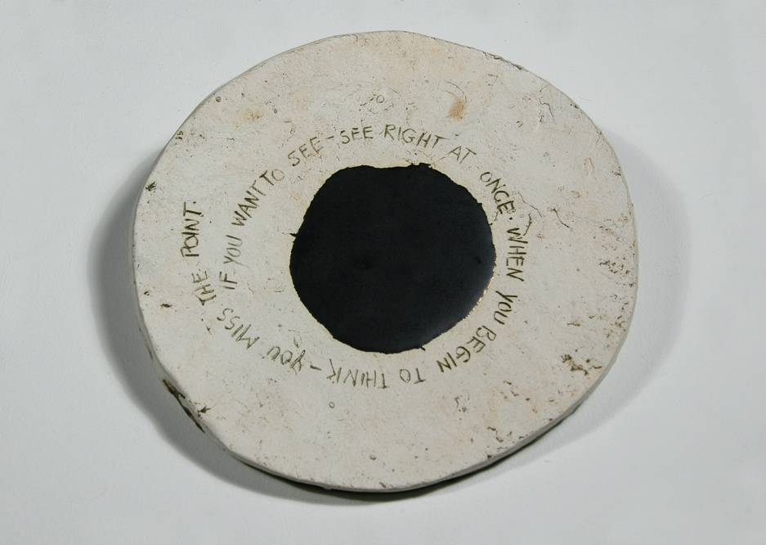 (Ariss, If you want to see …)

It appears fragile, as if waiting to be spotted, untended and away from its familiar position beside the teapot. As a consequence, Ariss’ viewer glimpses an art object with a distinctly minimal, and modern, Duchampian frame of reference. The spare, glazed black markings that spread across the gradual dip and swell of its ordinary, unglazed, white surface, trace a message about seeing that is not ordinary. A text, also the work’s title, reads: “If you want to see – see right at once. When you begin to think you miss the point.” Between the expected process of seeing and this unexpected encounter with a text about seeing, Ariss engages her viewer’s attention to the potential (my words, not hers) for immediate recognition that is possible in acts of seeing, and reading art. For her, further interpretation isn’t necessary. The questions and issues that slip through loopholes introduced in textual play across visual fields are necessary and important, especially those occasioned by encounters with the unexpected.

Seeing Greg Curnoe’s first View of Victoria Hospital series, 1968-69, is now indelibly marked in my memory. Painted text appeared to spread across the gallery wall. I remember seeing hand-stamped uppercase letters reaching from top to bottom, side-to-side: writing on the wall offering me different frames for seeing and a different perspective on transcribing the reality of this familiar view (for London, Ontario inhabitants). In this way, Curnoe questions what the representation of a landscape might be and what constitutes the practice of painting.

His paintings show the possibilities of a practice that operates across visual and literary fields. Appropriating technologies of printing and text production, he hand-stamped words on canvas. Yellow and Blue Printing, an oil painting on canvas from 1968, draws attention to the important role that process plays in the construction of his representation of “the top of the old dominion public building with blue sky around it, a maple leaf in the middle of the decorative area on the south façade …” When his writing reaches an edge, it continues on the next line, limited only by the space left. In this way, he addresses the limitations of the frame on what the viewer sees and its effect on limiting possible interpretations of experiencing and representing a sense of place.

Hunter’s premise for The Writing is on the Wall reflects Curnoe’s own concerning painting and text. Both exhibit a fascination with the possibilities of archiving and border crossing, and the transformative possibilities affected by such practice. For each, employing text transforms traditional art objects and expectations. Hunter’s viewers literally confront “writing on the wall.” Throughout the exhibition, there is evident subversive play with traditional generic forms implicated in the work seen.

Jennie White reminds her viewers that, for her, the text is the image, and that the process of looking and making meaning of her work literally depends on the viewer’s position or context. Her use of text: “what you see depends on where you stand,” also the work’s title, recalls Ariss’ 1969 If you want to see … about the processes of seeing and reading, and constructing knowledge, but White’s perspective is postmodern. She constructs her text using marks, in effect, “gouging’ her surface in a way that is reminiscent, but far more tempered than that of Paterson Ewen, her former teacher. (Hunter provides an earlier work by Ewen: Thundercloud as a Generator #1, an acrylic painting on canvas from 1972.) White uses dressmaker’s needles of various sizes to prick holes of different diameters through a two-dimensional paper surface. The effect is not unlike a pointillist drawing, although she constructs her texts three-dimensionally, literally flipping back and forth between the front and back surfaces of the textual body, her needle perforating the paper surface from either side.⁵ The result is a pattern of raised and voided areas, of light and dark, that may be read from either side, and from multiple access points.

These perforated works are diminutive, distant echoes of the ravaged surfaces of Ewen’s paintings, far more monumental in scale. He intervened with traditions of tightly held codes of landscape representation by introducing linguistic elements and directive signifiers, resulting in highly innovative readings of landscape phenomena. In White’s hands, the paper surface of the text becomes a plastic tissue, as she states, “a corporeal body.”⁶ For her viewer, the material play of solid and void signifiers, of light and dark, adds temporal shifts that prevent a fixed, unified reading. Her experiments with light and shadow recall Jack Chambers’ with silver paint in the mid-1960s, where, by effecting a movement of light suggestive of cinematic motion, he introduced a temporal shift into the viewing process. (An undated serigraph Untitled No. 4 from Chamber’s silver paint experiments is exhibited here.)

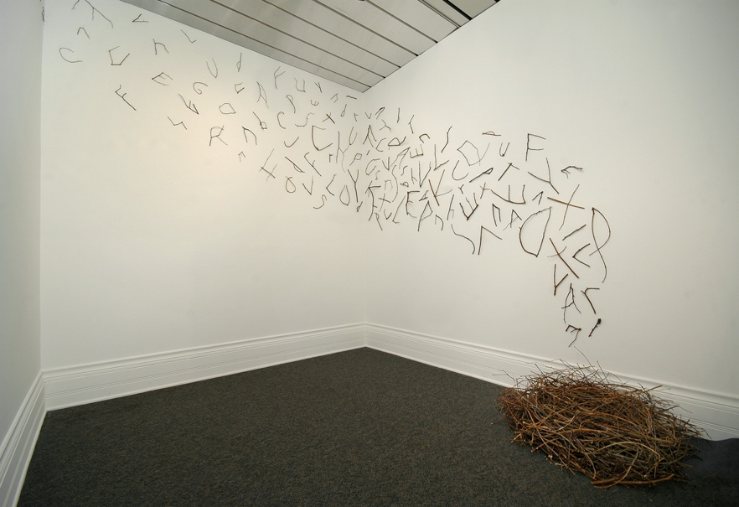 (Merritt, Talking Hole Burning)
David Merritt also addresses the activity of reading. His 1998 installation Talking Hole Burning is an uncanny mix of familiar household items: twigs, dressmaker pins, and audio, used very unconventionally. Pins, ordinarily a dressmaker’s or a map-maker’s tool, fix twigs to the gallery wall as incomplete letters, suggesting readable fragments of speech or an incomplete, drifting narrative, despite the impossibility of deciphering the letters and the random effect of being scattered. Indeed, the “work is littered with letters” as James Patten observes in his curatorial essay for littera, Merritt’s 1997-98 exhibition at Museum London and the Southern Alberta Art Gallery. To this, Merritt adds a single audio element emitted from a speaker nested in a bed of twigs on the floor. The sound of children’s voices practicing letter sounds, turned low, drifts; and disperses a sea of phonetic signifiers, which, like the incomplete stick-letters on the wall, are prevented from fixing and dispersing meaning. He literally lifts text off the page and allows it to unfold, drift and surround his viewer: in the process, this unreadable and incomprehensible nomenclature performs an improbable event of communication, where something unexpected occurs but meaning is not communicated: “There are only, everywhere, differences and traces of traces” (Derrida 26).
Text means Tissue; … we have always taken this tissue as a product, a ready-made
veil, behind which lies, more or less hidden, meaning (truth), … text is made, is worked out in a perpetual interweaving; lost in this tissue – this texture – the subject unmakes himself, like a spider dissolving in the constructive secretions of its web. (Barthes. The Pleasure of the Text 64)

The texts in Alpha Beta Data are amazingly fluid and dynamic. They literally stretch the visual possibilities of meaning making and for mapping visual knowledge, dashing expectations of what text is and might be. Foregrounded by standards of production embedded in historical traditions of literary practice and book culture, these visual texts resist and interrupt boundaries imposed by equally restrictive canons and codes of visual practice. They introduce strong, vocal threads of critically aware, disruptive voices to the visual fabric of contemporary cultural production, and they invite us to reconsider what is understood as the discourse of art and literature.

As curator and visual artist, Sourkes’ main concerns are the poetic possibilities of a practice that operates across visual and literary fields.⁸ Closely following the ongoing production of her peers, she culled work from their studios, some just produced. For her, as for Hunter, “text serves a number of functions and raises a variety of conceptual, formal and thematic concerns” (Hunter). Sourkes finds the different ways artists engage with script fascinating, especially the experimental, playful, material, lyrical textual practices of Michelle Gay, Vid Ingelevics, and Yam Lau.

Common Birds of Southern Ontario, Vid Ingelevics’ short video-installation work, offers a close encounter with unfamiliar speech-text acts: the unexpected linguistic word forms of ‘found’ speech acts of birds of Southern Ontario. Using “the floating, gimmicky titling options of Apple's video editing programme iMovie, the recorded sounds taken from a birdsong audio CD, and the mysterious written texts derived from those sounds as found in bird-watching guidebooks,” the artist gives these speech-acts textual form. In turn, these speech-acts perform the impossible task of giving sound to unreadable texts: “chjjjjjchewk” (Ingelevics). These disconnected signifiers, as Sourkes observes, “drift through the air, skirt the upper walls, leaving visible traces of this unreadable system of representation.”⁹
the Invisible / summons the wind / into bounds, / you read.
(Celan “Rebleute Graben”)

Picture a text that remains invisible until immersed in water. Then, represent the message it carries in a bottle. To make that suggestion, Yam Lau etched Paul Celan's last poem, “Rebleute Graben” (“Vinegrowers dig up”) in reverse on the outer surface of a hand-blown glass bottle (Celan 376-77). The etched text is projected within the water of the bottle to facilitate reading.

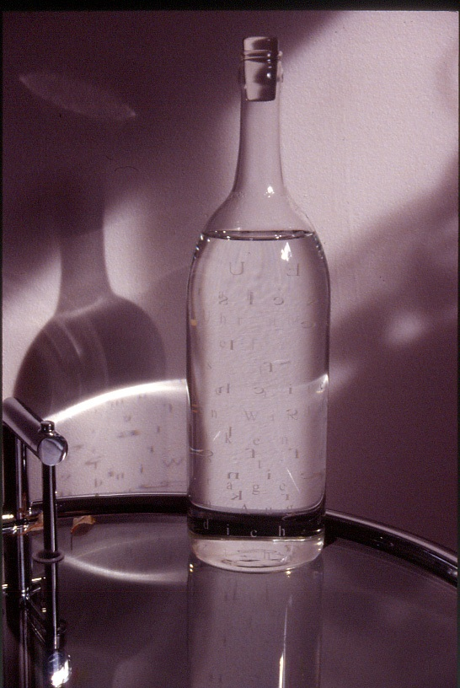 (Lau, In the River …)

Lau created In the River, North of the Future, 2001, to commemorate the poet Celan, who characterized his poems as “a message in the bottle” (Lau). Celan drowned himself in the Seine River in 2005. The glass book holding contributions by other artists in the project sealed within it will be released into the Seine on the anniversary of his death.

Michelle Gay’s poetic experiments in virtual space literally explore the textual fabric of poetry as a dynamic and transformative tissue. Citing “the loom, the computer and (il)logic”¹⁰ as key sources, she locates her play with language at the disciplinary edges of drawing, installation, and new media. LoopLoop, from Experiments with A Reader, begun in 2002, is a screen and projection text work where a mouse operates as a site for human interface and bestows what she describes as, “a visceral connection to these virtual play/data spaces” (Gay). Sites of intersection between digital and actual spaces and between bodies, psyches, and technologies have always allured her. For a decade, she notes, she has been “using code to drive animation, interactivity, and audio elements within computer works … taking the machine itself out of the realm of the common workstation and luring into the realm of the poetic” (Gay).
what if i repeat/forgot and time washes away
erode loop;
else if i; loop;
do quickly now;
wrap myself in an axiom
redress the feral data;
smell the numbers
loop;
loop;
else if i;
(no longer know who I am);
do latch upon;
the corners of myself;
bathe and then erase;
and/or count like an animal;
swallow the set;
loop;
loop;
do next i;
(Gay LoopLoop)

Readers and viewers of LoopLoop, 2002- ¹¹ find the reading process continually unravels, braids and re-braids … The construction of meaning is always in process, continually intervened in by the reader, and transforming itself.
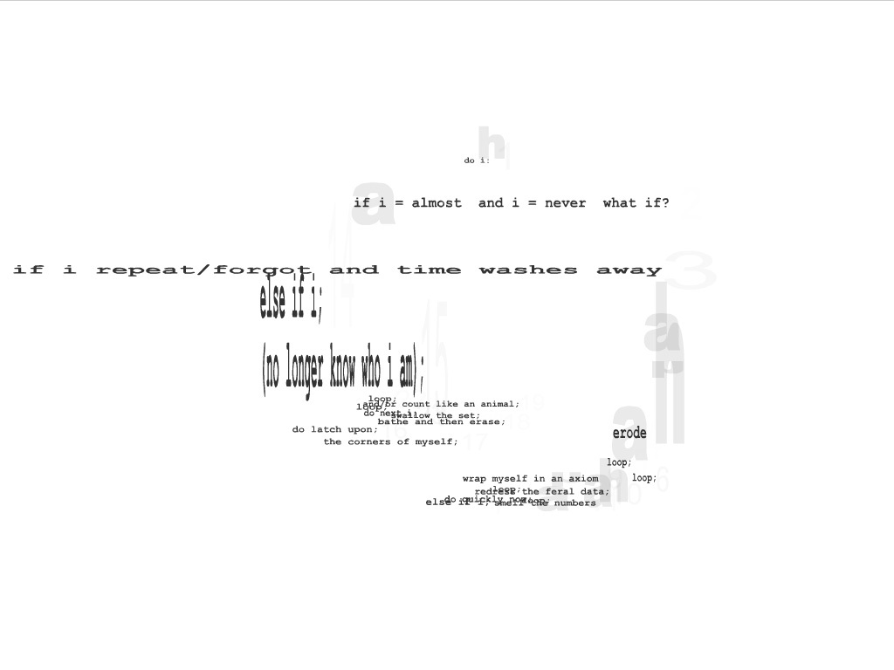
(Gay, looploop_frame03)

Without a reader, the task is suspended until picked up by another. As Sourkes describes: “the moving cursor attracts, morphs and reconfigures lines of text”¹². This unfamiliar and unexpected process of reading and re-reading textual threads of Gay’s poem, each line driven by a line of code, into a ‘braiding’ that transforms as soon as “the hand intervenes to gather and intertwine the inert threads,” recalls Barthes on the production of text, where “at the same point in the narrative (it could be at another) several actions are still underway at the same time … are still in process, suspended and interwoven” (Barthes S/Z: An Essay 160).

Cheryl Sourkes’ visual strategies are deliberate and disruptive. Her text is virtual, a tissue that stretches and blurs the boundaries of private and public discourse. Clearly, intimate, private spheres allure her because they offer a wealth of what she describes as “unanticipated” images of “life off-screen” to work with; however, she immediately disturbs the illusion of intimacy by framing these private messages for all to view (Sourkes). She transgresses the candid, occasionally rhetorically seductive, exchanges between homecammers, who are, she says, “ordinary people who use webcams to disseminate things they care about to the world at large – themselves, their family members, their homes, their evangelical messages, whatever” (Sourkes).

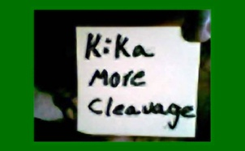 (Sourkes, Kika more cleavage)

Lifting texts, she describes as a “a kind of cross between personal ad and phone sex” into public sight, changes and opens up the potential to engage and to respond (Sourkes). In the gallery site, such private text exchanges become public visual acts, providing her viewers with unexpected, sexy, meaning-making possibilities.

 (Laing, Claudian Letters)

On the north wall, Carol Laing’s blown-up Claudian letters hover, uncanny and silent, at eye level. Their appearance is disturbingly familiar for the letters are indecipherable and recall an earlier textual investigation concerning (dis)similarities she conducted in her catalogue essay for (K)ein Vergleich, 1991, at The Southern Alberta Art Gallery: “What happens when elements of discourse we know become, themselves, pictures” (Laing. (K)ein Vergleich 8) (The italics are mine.). Here they recover something absent and unknown. She states that The Claudian Letters: add>delete>type>insert document the reclamation of lost linguistic elements into the symbolic present. Each of four standard, letter sized, mixed media paper panels, fixed to the wall at even intervals just inches apart, ‘pictures’ the appearance, disappearance, reappearance, and transformation of the same content in symbolic transcriptions across two millennia. Her research shows that during his reign, the Roman Emperor Claudius (41-45 AD) added the glyphs or forms of the three Claudian letters to the Latin alphabet to represent missing sounds, each a variant on the template of an existing letter: a reversed C, an inverted F and a half H. With Claudius’ death, the letters were deleted from the alphabet, and remained typologically unavailable in all computer font systems until a recent proposal added them to the Universal Character Set (UCS) giving mathematical code points in Unicode, restoring the original upper case glyphs and adding a set in lower case to meet casing requirements and concerns for theoretical symmetry (Laing. Artist statement). In the process of ‘picturing’ the letters’ reclamation from a lost state to concise Unicode function, Laing witnessed the unexpected, subversive play of human existence and the possibility of transformation for the world: “where things go backwards, turn upside down, or are cut in half … Where things disappear and then –” she says, “after long intervals – return. Changed” (Laing. Artist statement).

In The Writing is on the Wall and Alpha Beta Data, curators Hunter and Sourkes investigate how incorporating textual strategies in the process of making art, as these artists do, transgresses the limitations of frameworks imposed by traditions of historical, cultural, and material art practices, and their corresponding systems of thought. They introduce viewers to different ways of seeing and reading, and different sights and readings, by engaging in the network of connections and interconnections of sensations and experiences inscribed on these walls. In this way, they authorize the public spaces of art museums and galleries as places for performing “alternate ‘readings’ of human experience from inside” sites of culture where “art practice can be understood as a form of social activity, both rule-governed and open” (Laing. (K)ein Vergleich 10). For the artists, employing textual strategies in their visual practice opens disruptive possibilities for transgressing the construction of knowledge in ‘the symbolic.’ Such acts are performative and resist easy reading for each encounter is unpredictable and unexpected.

Notes
¹ Alpha Beta Data was exhibited at akau inc., Toronto, August 5 – September 2, 2006 and The Writing is on the Wall, at Museum London, London, Ontario, September 6, 2006 – August 26, 2007.
² From an e-mail from Jamelie Hassan, 7 August 2007.
³ In an e-mail from 7 August 2007, Jamelie Hassan notes: “ى in English is pronounced ‘Yaa’ (like Yeah slang affirmative).”
⁴ An e-mail dated 7 August 2007 from Jamelie Hassan states: “During my research at the Bibliotheca Alexandrina I saw in their manuscript collections many fine examples of manuscripts in many scripts. One insightful comment in the text material was that red ink was often used to highlight the beginning of a new thought, as punctuation was often not a part of the writing. Red ink was also used to highlight the pronunciation of sounds and vowel & other accent marks for reading.”
⁵ Conversation with Jennie White on 7 January 2007. For an informed reading of White’s perforated works see Madeline Lennon’s essay “Everything grows on everything else.” Home Again. McIntosh Gallery, The University of Western Ontario. London, Ontario, 2004. n. pag.
⁶ Conversation on 7 January 2007 with Jennie White.
⁷ “Littera is the Latin word for letter. It is also similar to litter, in the sense of a layer of twigs and leaves randomly scattered on a forest floor, from the Latin lectus, meaning bed. In this exhibition the two words overlap, folding into one another: the work is littered with letters …” (Patten 11).
⁸ Conversation with Cheryl Sourkes on 24 August 2006.
⁹ Sourkes’ words echo Carol Laing’s, for example, “there’s a delicate scatter of sticks, as if whirled outwards from some centre … flickering and changing as I move” in her text contribution to David Merritt’s littera “Notes, in passing …” (30-31). From a conversation with Cheryl Sourkes on 24 August 2006.
¹⁰ From “Notes on some works with text” provided by Michelle Gay for Alpha Beta Data. See also Ingrid Bachmann’s “Material and the Promise of the Immaterial.” (Material matters 23-34).
¹¹ From looploop frame01 from Michelle Gay’s series Experiments with a Reader, begun in 2002 and exhibited in Alpha Beta Data at akau inc. September 2006.
¹² In her curatorial statement, Sourkes describes the interactive/performative/transformative process of LoopLoop: “the moving cursor attracts, morphs and reconfigures lines of text.”

Visual Works Cited

From The Writing is on the Wall, in the Collection of Museum London. Photo credit for all three images: John Tamblyn

Margot Ariss (Canadian, 19290929 - )
If You Want To See - See Right At Once. When You Begin To Think You Miss The Point, 1969.
Glazed And Unglazed Ceramic, 19.7 Cm Diameter
Collection Of Museum London, Gift Of Richard And Beryl Ivey, London, Ontario, 1996
Cat. No. 96.A.112

David Merritt (Canadian, 19550916 - )
Talking Hole Burning, 1998
Sticks, Dressmaker Pins, Audio
Collection Of Museum London, Purchased With Matching Funds From The Canada Council Art Bank And The Volunteer Committee, 1999
Cat. No. 99.A.36

Hassan, Jamelie (Canadian, 19480901 - )
ى (Manuscript Page), 2005
Colour Photograph And Neon Light On Panel, 61 X 76.2 Cm
Collection Of Museum London, Purchased With Financial Support Of The Canada Council For The Arts And Matching Funds From The Volunteer Committee, 2006
Cat. No. 006.A.003

From Alpha Beta Data

Michelle Gay
LoopLoop (from the series Experiments with A Reader), 2002-
Interactive digital media

Carol Laing
The Claudian Letters: add>delete>type>insert (A piece for alpha beta data), 2006.
Mixed media on paper

Yam Lau
In the River, North of the Future, 2001
Artist’s book in commemoration of Paul Celan
Hand blown glass bottle, etching, water

Cheryl Sourkes
Homecammers-messages: Kika more cleavage, 2008
Digital prints

Works Cited

Bachmann, Ingrid. “Material and the Promise of the Immaterial.” Material Matters: The Art and Culture of Contemporary Textiles. Ed. Ingrid Bachmann and Ruth Scheuing. Toronto: YYZ Books, 1998.
Barthes, Roland. The Pleasure of the Text. Trans. Richard Miller. New York: Hill and
Wang, 1975.
_____. “LXVIII. The Braid.” S/Z: An Essay. Trans. Richard Miller. New York: Hill and
Wang, (1970) 1974.
Basile, Elena. “Professor Barbara Godard In Memoriam Department of English, September 8, 2010.” Footnotes 1 (2010): 5-6.
Celan, Paul. “Rebleute Graben.” Selected Poems and Prose of Paul Celan. Trans. John
Felstiner. New York: W. W. Norton, 2000.
Derrida, Jacques. Positions. Trans. Alan Bass. Chicago: University of Chicago Press, (1972) 1981.
Gagnon, Monika. “Unravelling the everyday: the art installations of Jamelie Hassan.” Laureates/Jamelie Hassan 2001-2002. 17 Feb. 2007 <http://
www.conseildesarts.ca/prizes/ggavma/xh127240204281875000.htm>
Gay, Michelle. “Notes on some works with text.” Alpha Beta Data. 2006.
Godard, Barbara. “Flying away with Language.” Lesbian Triptych. Jovette Marchessault.
Trans. Yvonne M. Klein. Toronto: Women’s Press, 1985. 9-28.
_____. “Preface.” Picture Theory. Nicole Brossard. Trans. Barbara Godard. Toronto: Guernica, (1982) 1991, 2006. 7-12.
Godard, Barbara et al. “Editorial Statement.” Room of One’s Own 8.4 (1984): 3-4.
_____. “SP/ELLE: Spelling Out the Reasons (1983).” Room of One’s Own 8.4 (1984): 4-18
Hunter, Andrew. “Curatorial Statement.” The Writing is on the Wall. 2006.
Ingelevics, Vid. “Artist statement for Common Birds of Southern Ontario.” Alpha Beta Data. 2006.
Laing, Carol. “The Claudian Letters: add>delete>type>insert (2006): A piece for Alpha Beta Data.” Artist statement. Alpha Beta Data. 2006.
_____. “(K)ein Vergleich: Different, and the Same.” (K)ein Vergleich = (Dis)similarities: Silvia Bächi, Thérèse Bolliger, Cathy Daley. Lethbridge: Southern Alberta Art Gallery, 1991.
_____. “Notes, in passing …” littera: David Merritt. London Regional Art and Historical Museums. London, Ontario, 1997; The Southern Alberta Art Gallery. Lethbridge, Alberta, 1998.
Lau, Yam. “Artist statement for In the River, North of the Future.” Alpha Beta Data. 2006.
Marks, Elaine and de Courtivron, Isabelle. “Why this Book?” New French Feminisms. New York: Schocken Books, 1981. ix-xiii.
Patten, James. “David Merritt: littera.” littera: David Merritt. London Regional Art and Historical Museums. London, Ontario, 1997 and The Southern Alberta Art Gallery. Lethbridge, Alberta, 1998.
Sourkes, Cheryl. “Artist statement for Homecammers-messages.” Alpha Beta Data. 2006.
Woolf, Virginia. “A Conversation about Art.” Yale Review 24.1 (1934): 52-65.
_____. “Walter Sickert (1934).” Collected Essays. London: Hogarth Press, 1972. 2: 233-44.

